**Assignment 04**

Write a c++ program to implement Method Overloading with your own application.

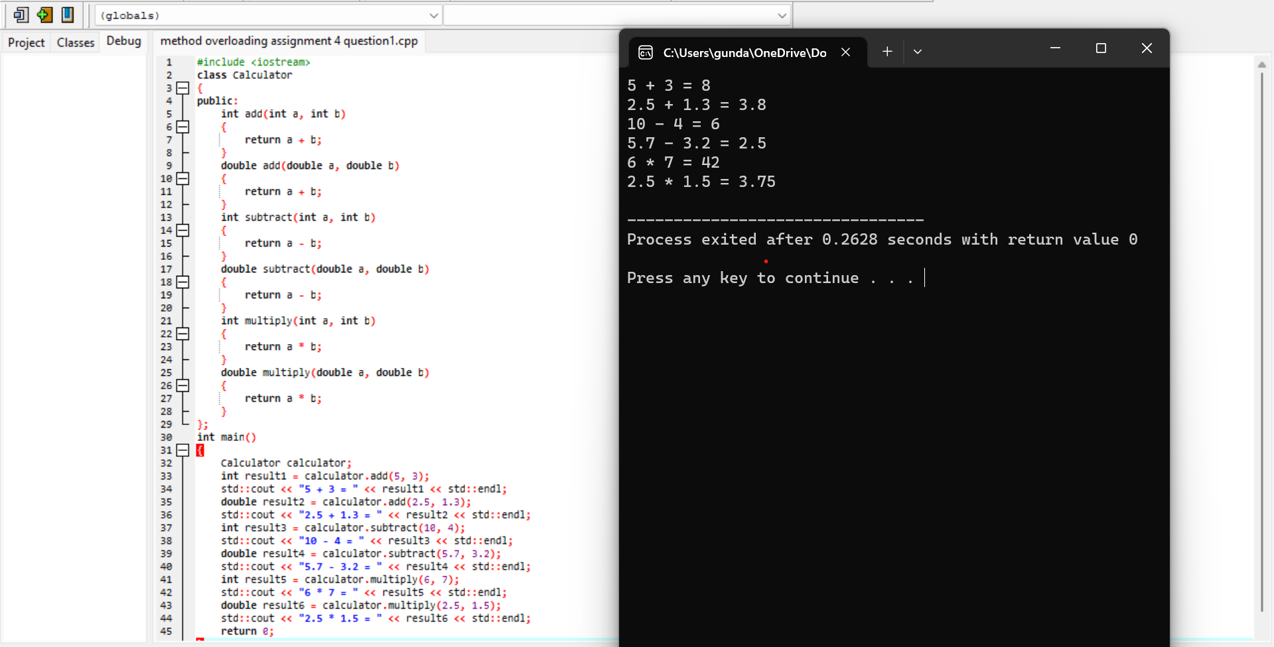

write a c++ program to implement a friend function

